**Assignment 4**

**Name – SURAJ KUMAR YADAV**

**ROLL NO. – 20220PHY014**

1. **Design a BCD to Excess – 3 code converter**
   1. 1001 to excess – 3 code

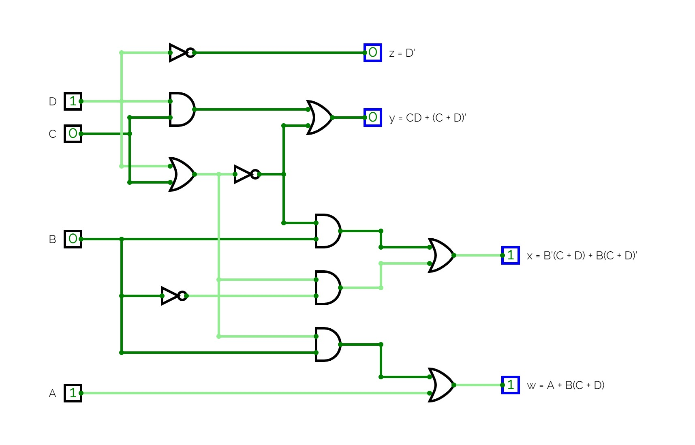

* 1. 0111 to excess – 3 code

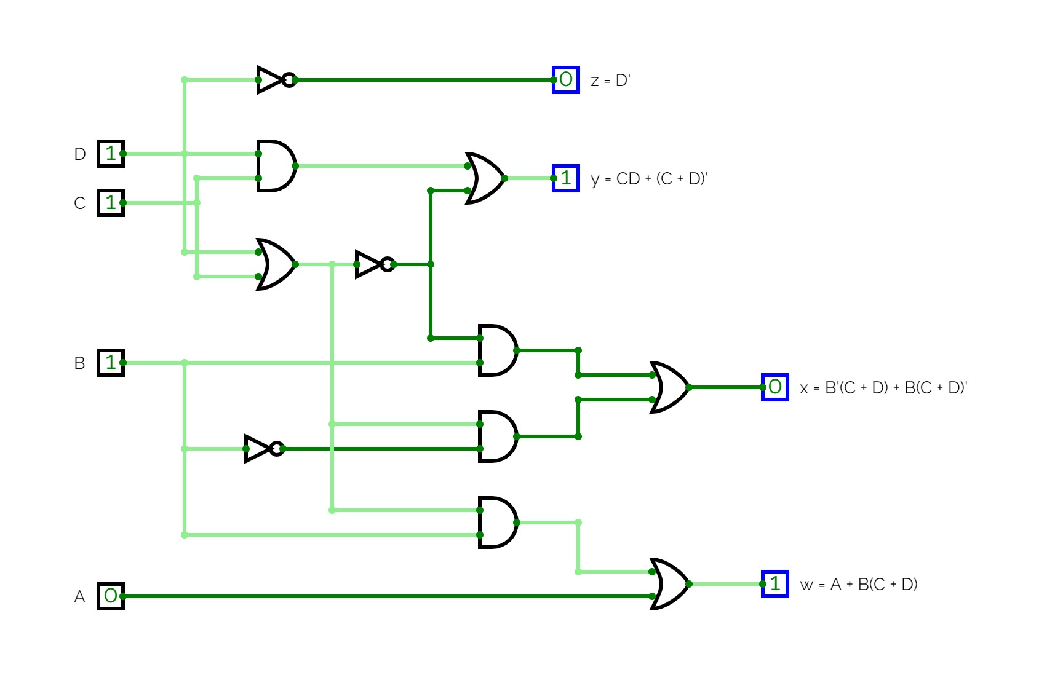

1. **Design a 3 to 8 line decoder**
   1. x = 1, y = 1, z = 1

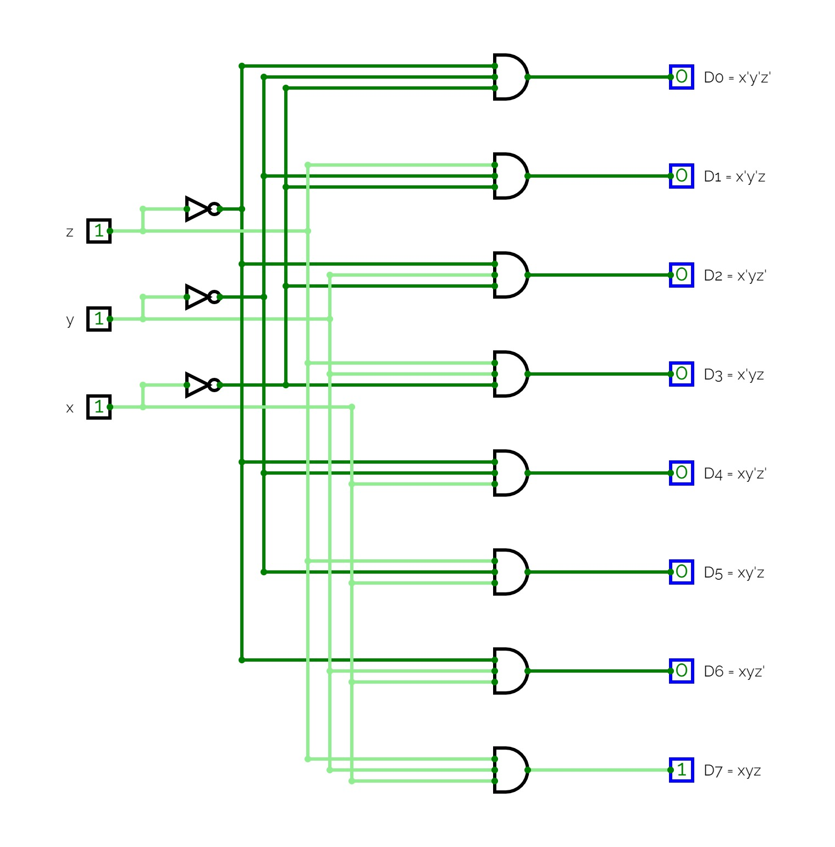

* 1. x = 1, y = 0, z = 1

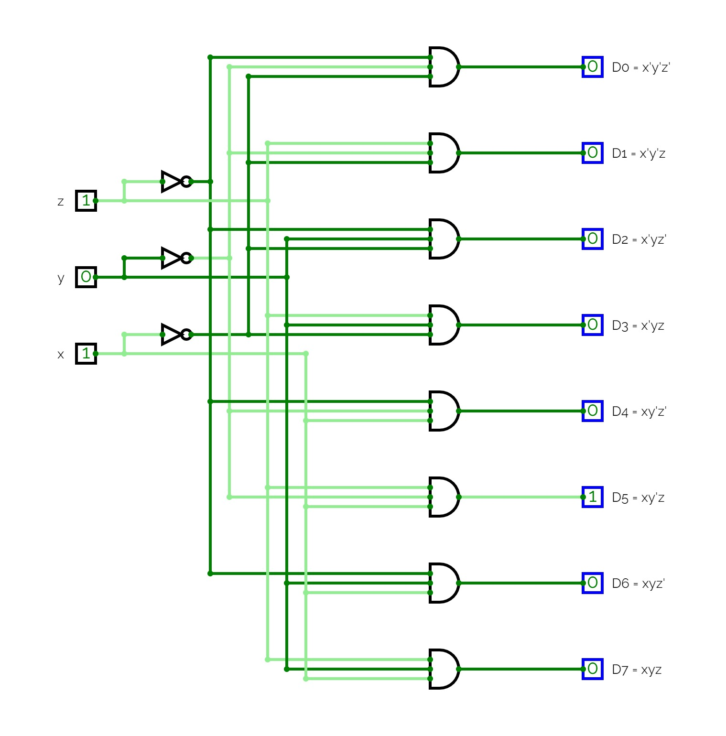

1. **Design a 8 to 3 line encoder**
   1. D0 = 0, D1 = 1, D2 = 0, D3 = 0, D4 = 0, D5 = 0, D6 = 0, D7 = 0

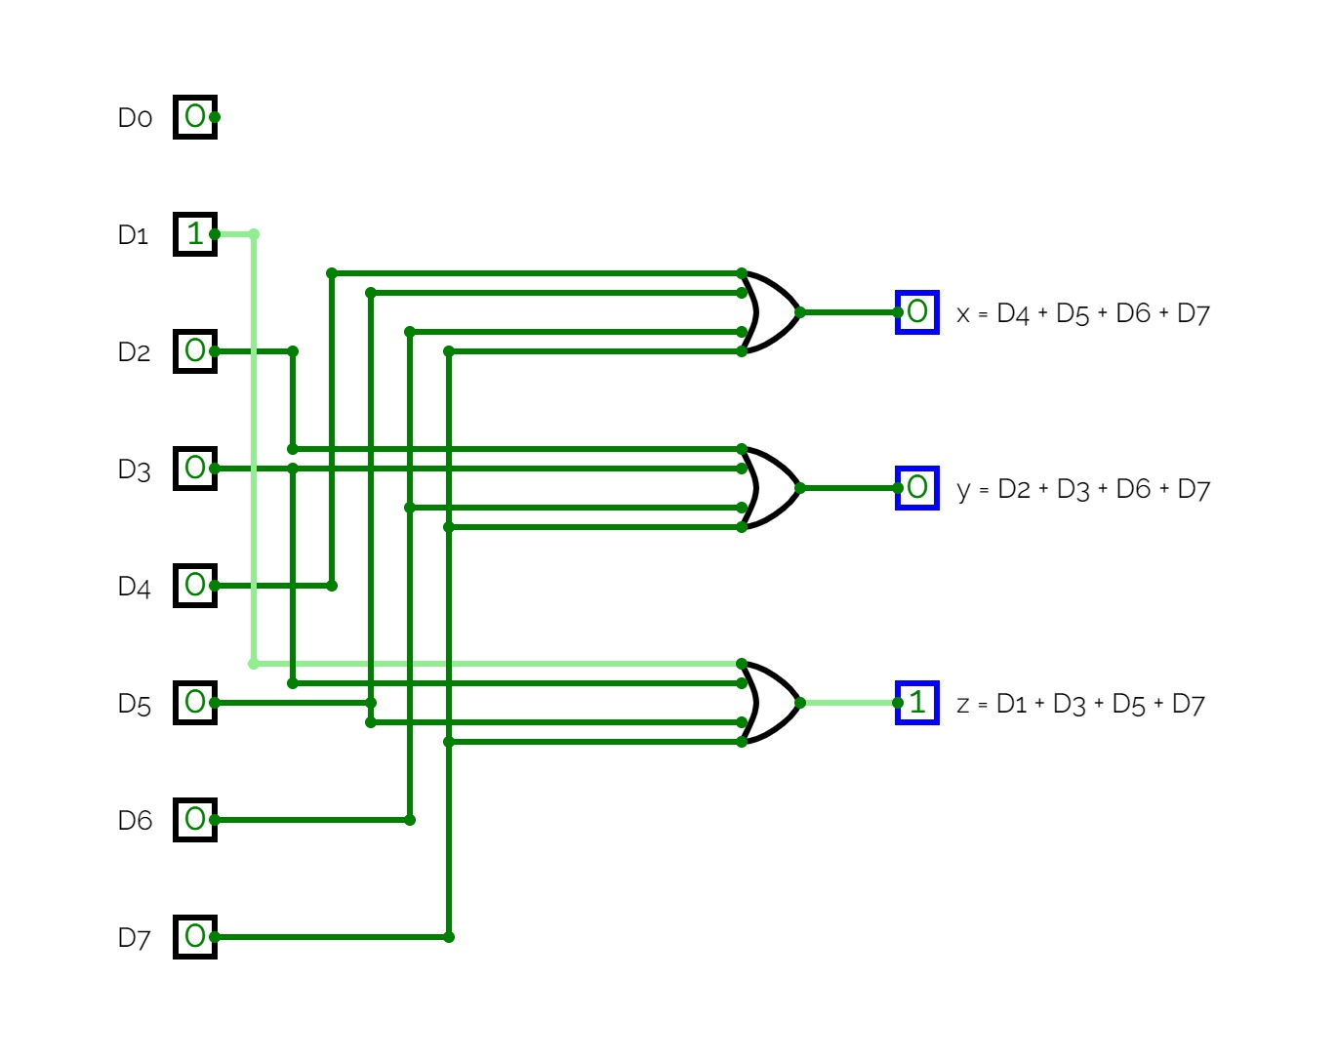

* 1. D0 = 0, D1 = 0, D2 = 1, D3 = 0, D4 = 0, D5 = 0, D6 = 0, D7 = 0

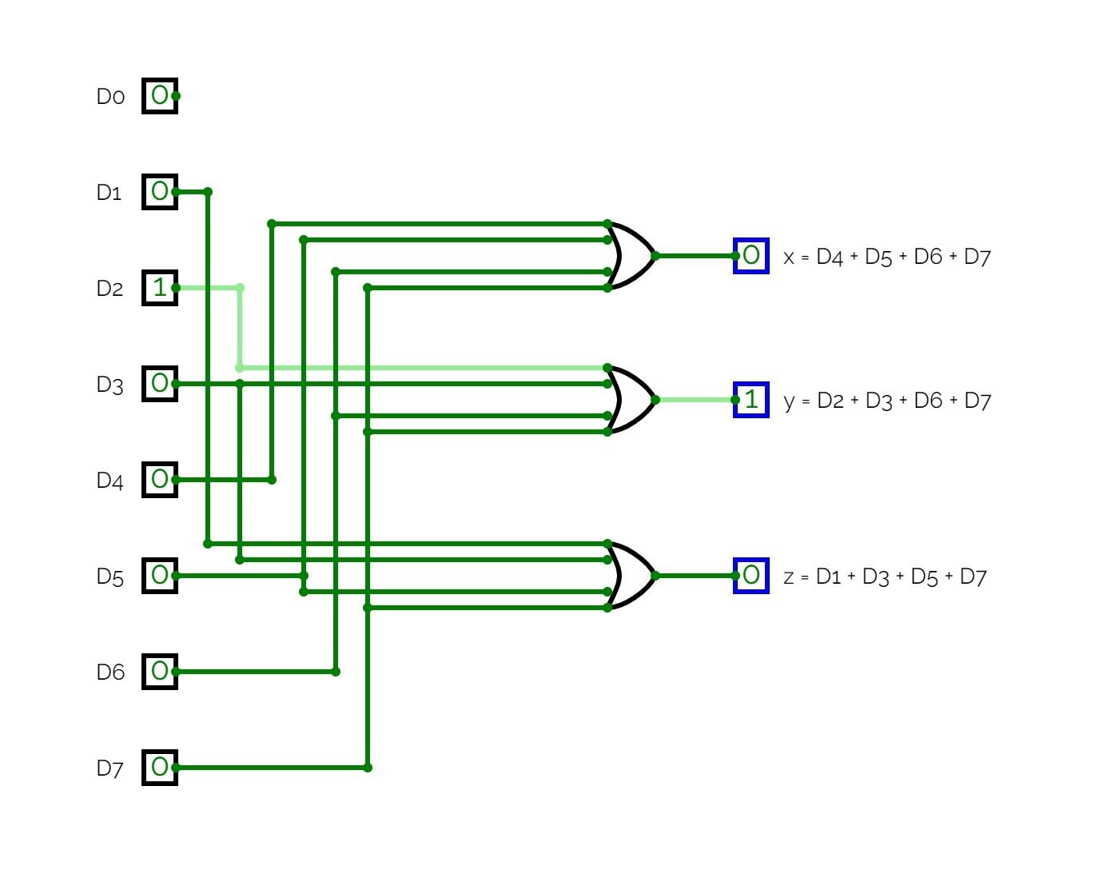

1. **Implement a full adder using decoder and two OR gate**
   1. Add 1, 0, 0

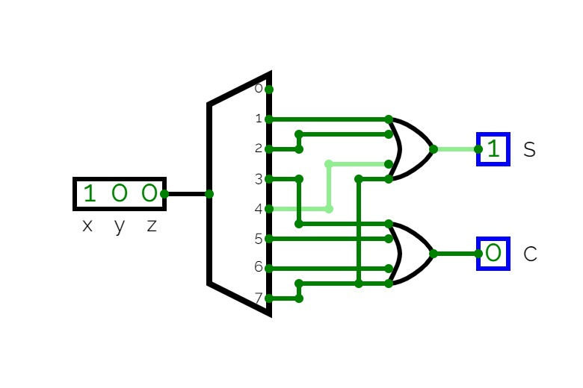

* 1. Add 1, 1, 0

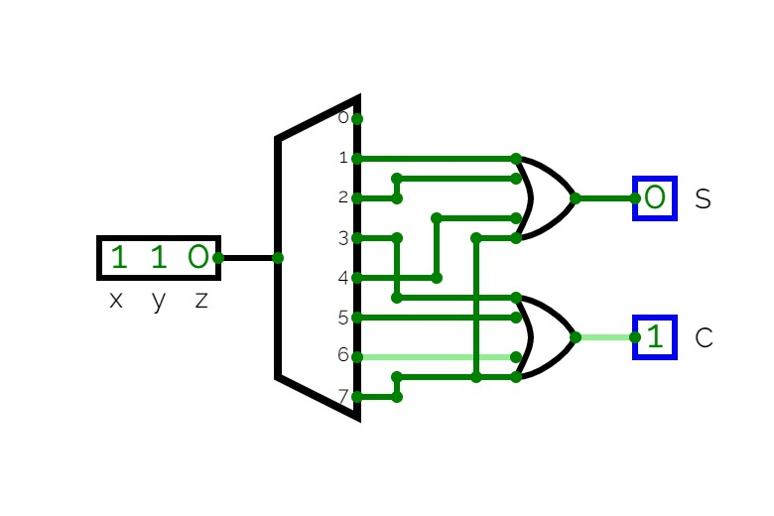

1. **Implement full Subtractor using decoder**
   1. Subtract 1, 0, 0

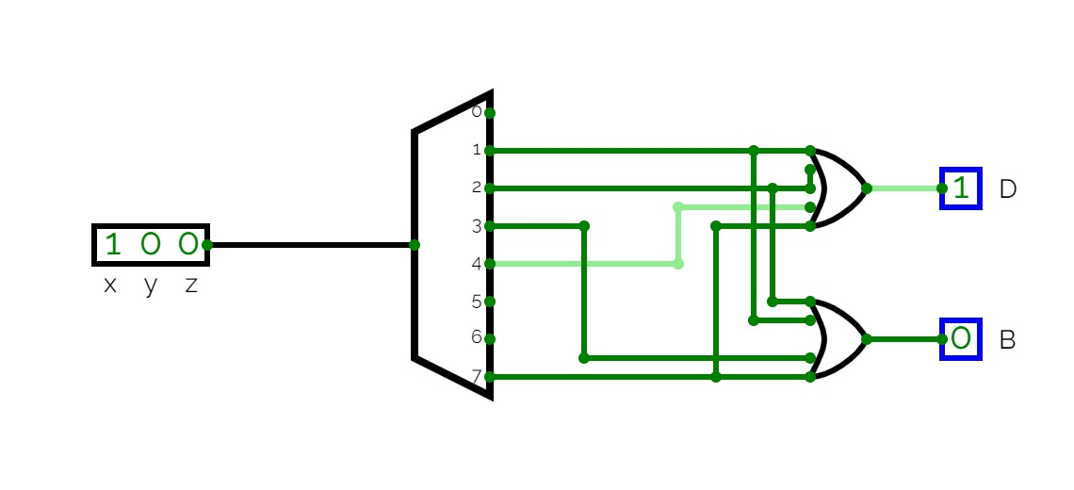

* 1. Subtract 1, 1, 0

